**Project Report**

**Role:**

The project is solely done by me.

**Learning outcome:**

Basics of HTML5, CSS

**Course taken:**

My captain web development course

**Libraries installed:**

Bootstrap

jQuery

**Work flow:**

* Deciding requirements in the website
* Designing framework of website
* Coding in HTML
* Styling with CSS

Repository link:

<https://github.com/sans007/ieee-project1>

Screenshots:

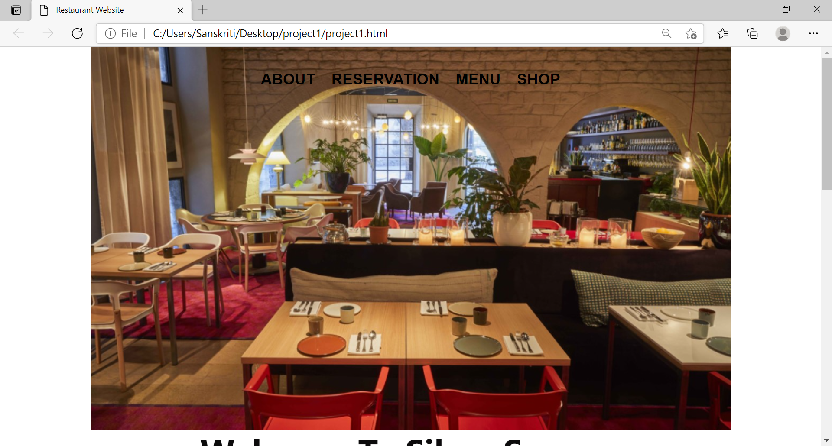

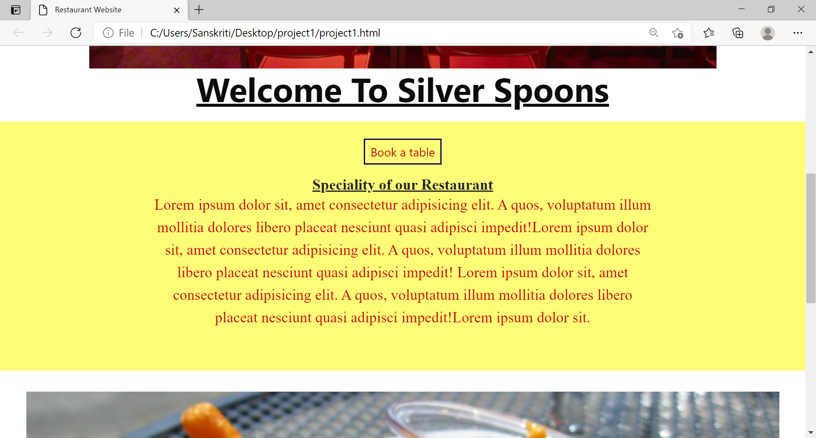

Carousel:

